**FROM: Nancy Orvis**, Chief Business Architecture,

Health Standards & Interoperability Health Care

Ops/Clinical Support Division/ Office of Information Management Defense

**Stephen Hufnagel**, FHA: FHIM and HL7: CIMI Facilitator

**SUBJ:** Trip Report for Health Level 7 Workgroup Meeting, Madrid

**DATE:** May 7-12, 2017, Last updated May 17, 2017

**LINK:** <https://1drv.ms/f/s!AlkpZJej6nh_lNAkUhPiFYWuT0L8xQ> for report and referenced documents

This report assimilates HL7 meeting observations from multiple persons’ perspectives.

1. **Nancy Orvis (MHS Perspective)**
   1. Mon Q1-2 Plenary Session on European Health Interoperability
      1. Key Output – Conversation with Dr. Amir (sp?) of NHS Britain and InterOp organization about this and NATO MEDCIS; will follow up with him on levels of interoperability or briefings on said items.
   2. Mon Q3 - CIMI Agenda Planning and Scheduling
   3. Mon Q4 - CIMI work items; worked on Genetic and Precision Medicine items with Cat Lasome, AF representative present at the meeting.
   4. Tue Q1 – EHR Workgroup
   5. Tue Q2 – Structured Documents
   6. Tue Q3-4 HL7 Board Meeting from 2:45 – 6:30 pm
   7. Wed Q1 - Clinical Interoperability Council – Discussion with Anita Walden on key aspects of the registries project
   8. Wed Q2 – Structured documents - discussion on Ballot 1297 comments on UDI –
      1. Key Output – Determined No decisions on DoD comments could be made at the meeting; will be done on phone calls, as the proponent/writers of this portion of the ballot were not present at the meeting.
   9. Wed Q3 & 4 – Clinical Interoperability Council and Belgium/Dutch Registries Integration Project
      1. URL is “Healthdata.be “at a glance
      2. 42 Building Blocks from the Continuing Care Document are in a REST API Java Script Implementations
      3. __www.Healthdata.be_____________- Name and URL
   10. Information Architecture was considered to be the integrating functions
   11. In production, N=20 registries in Belgium Started with
       1. Registries still To Do N>100
       2. ACTION: Get slide deck
   12. Ph1 – Map existing Registries to CBB; get briefing slides from Anita Walden
   13. Ph2 -
   14. Ph3 –
   15. Interfaces without CBBs - necessitate point to points and wished to avoid n x n
   16. Interfaces with CBBs Input formats CBBs Registries (n) n+n to maintain
   17. EMRs Basic Dataset
       1. LIMS HL7v3 CDAr2
       2. EHR HL7 FHIR
   18. No solution for the 33% of data that are questions specific to the registry. Found 67% of data could be mapped to the Common Building Blocks
   19. AMS give presentation on the models in the DAM for Registries
   20. What is the data look like when it’s submitted, when it’s at rest, and when it’s used.
   21. He used the RIM classes for the Data at rest model 1 other Wed
   22. Actions for me from Anita Walden and Laura Heerman of IHC. _ Brief Jill Sterling on the issue and attendance for decision makers, Misty Blocker, Robert Ward and Carl Barker --- DoD needs to be there with a common approach – with someone who can decide- is there an internal organizational quality/verification check before data is sent to a registry? Will MHS do that? Need to insert the Belgian Health system project. They found that 67 % of data (about 33% is core demographics, 33 % is key clinical common cored) and then 33% in the third outer ring are questions and answers particular to that unique registry and cannot be shared commonly. Belgian Health Registries Modeling Project
   23. Registry Overlaps
   24. Thu Q1- Discussion with David Booth of FHIR LDSR R&D Project (CFR Gov ID ?? - ) Key takeaway—Can he identify where DoD needs to submit additions and suggestions to FHIR Resources. Also talked to Mark of IPO/MITRE re-creating a documented list of these. Action for David Booth --- report data maps and gaps needed for CHCS and FHIR to me and the MHS Data Management Board and they will be registered there.
   25. Thu Q2 - EHR Workgroup – Key output – discussion of Immunization Profile and Use Cases to include not only 100 children coming in for mass immunization (birth to 18) to include working people (job related/Military) needing batch requests to get the Immunization medication from the pharmacy to dispensation to a known group of patients.
       1. Item 2: brief review of EHR-S Registries Profile. Suggested word changes from “Establish functional requirements” to “Extract and validate Functional Requirements” from the project itself.
   26. Thu Q3 - Worked on report
   27. Thu Q4 - CIMI Output – Strategic Plan for next ballot and next 2 years; key output – will stay in contact with Richard ?? in order to execute on RADLEX/LOINC and linking to Radiology Orders.
2. **Steve Hufnagel (FHIM-CIMI IIM&T-Project Perspective)**

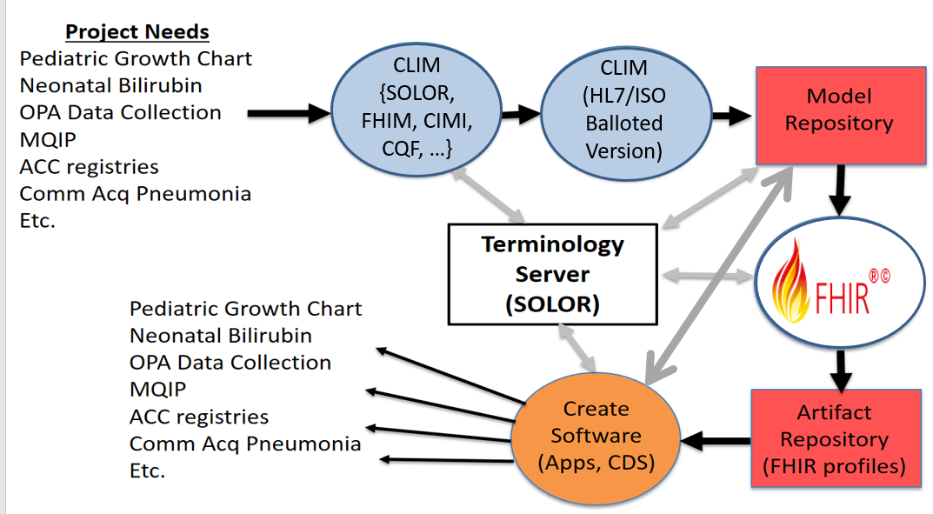

**Figure 1 Conceptual IIM&T MDD SDLC**

**EXECUTIVE SUMMARY**: The Healthcare IT mission-needs epiphany-of-the-obvious is that integrated information models and tools (**IIM&T**) within a model-driven-development (**MDD**) environment on the SDLC path[1] to consistent-and-traceable FHIR and CDA profiles-and-extensions is the next-step to achieving “faster-better-cheaper” patient-healthcare value, e.g., improved patient-outcomes at lower-cost. Engaging clinicians requires intuitive, i.e., intuitive user-interfaces for full-lifecycle MDD tools from requirements-specifications to logical information-models, to FHIR-and-CDA implementation-and-test artifacts; where, crown-sourced and crown-curated reuse-libraries of these artifacts can support scalability. Healthcare IT’s technical objective is “plug-and-play computable-semantic-interoperability”, which is easy-to-say, hard-to-achieve and is the key requirement of “learning health systems” and ‘patient-centric population-based medicine”. CLIM[2] (SOLOR, FHIM, CIMI, CQF, FHIR/CDA profiles and extensions) is maturing in achieving consistency-and-traceability across implementations; but, there are too few experienced clinical-modelers/informaticists, too little time and too high a cost for the current centralized approach to scale. FHIR focuses on crowd-sourcing, has a high uptake and is maturing its implementation core-resources, profiles-and-extensions; but the current FHIR-processes are ad-hoc and do not inherently-maintain consistency-and-traceability; where, we need a scalable, traceable and consistent approach; where, this might be achievable by the integration of the IIM&T-and-FHIR methodologies-and-tools.

At the HL7 meeting, we discussed

* 1. [FHIR](http://hl7.org/implement/standards/fhir/) (Fast Healthcare Interoperability Resources) is a specification for exchanging healthcare data in a modern and developer friendly way. HL7 **FHIR** core is maturing, with less change in Standard for trial use (STU3); although, pharmacy/medications had many additional attributes. FHIR structure definitions tools are improving with the addition of <http://clinfhir.com/> (see appendix for detail) and <https://simplifier.net/> as an open-source repository of FHIR models/profiles/extensions; although, Simplifier’s search capability is primitive and requires hierarchy to make it saleable. One problem is that profiles on profiles with extensions can be become unrecognizable from the base FHIR core resource. Graham Grieve is encouraging organizations to have their own connectathons to verify and validate their implementations; where, many developers are running many concurrent virtual machine test beds.
  2. Another major step forward is the extraction-transformation-load (**ETL**) advancements for relational database legacy-data, using HAPI FHIR (FHIR made easy open-source HAPI-FHIR implementation library of the FHIR specification in Java).
  3. Now that FHIR Standard for trial use Release 3 is published, here are the main priorities for the next FHIR release:
     1. **Normative**: push to normative for
        1. Foundation / API / XML / JSON / Bundle / OperationOutcome
        2. Terminology Service (ValueSet / CodeSystem / ExpansionProfile)
        3. StructureDefinition / CapabilityStatement
        4. Patient / RelatedPerson / Practitioner / Organization / ?Endpoint
     2. Position a **core set of clinical resources** (‘health base’?) for normative in R5 (or Observation | AllergyIntolerance | MedicationStatement normative for R4?)
     3. **JSON**: use manifest for extensions, parameters resource ([see blog post](http://www.healthintersections.com.au/?p=2626)) (note that discussion on this didn’t go very well – probably will be dropped)
     4. **RDF**: more ontology bindings + resolve status of JSON-LD
     5. **Data Analytics**: support for a bulk data analysis bridge format (Apache Parquet?)
     6. **API:** better control over retrieving graphs, and value added query support (tabular format?)
     7. **Patterns**: change the W5 framework to a pattern (logical model), tie the patterns to ontology, and use of patterns to drive more consistency (and how to do this without decreasing quality)
     8. **Services**: more services. Candidates: conformance, registry, personal health summary?, etc.?
     9. **Deployment**: get a clear standards path for smart on FHIR / CDS-hooks (and alignment with UMA/Heart)
     10. **FHIR Management (FM)**: work on alignment between FM resources and the rest of FHIR

**Note** that this list is written anticipating that the normal standards development processes occur, and the content as a whole is maintained; where, this will amount to 1000s of tasks. So this list is not a list of ‘what will change in R4’, but an indication of where particular focus will be applied by the FHIR leadership (so don’t be concerned if a particular issue of yours is not on this list, as long as it’s in [gForge](http://gforge.hl7.org/gf/project/fhir/tracker/?action=TrackerItemBrowse&tracker_id=677))

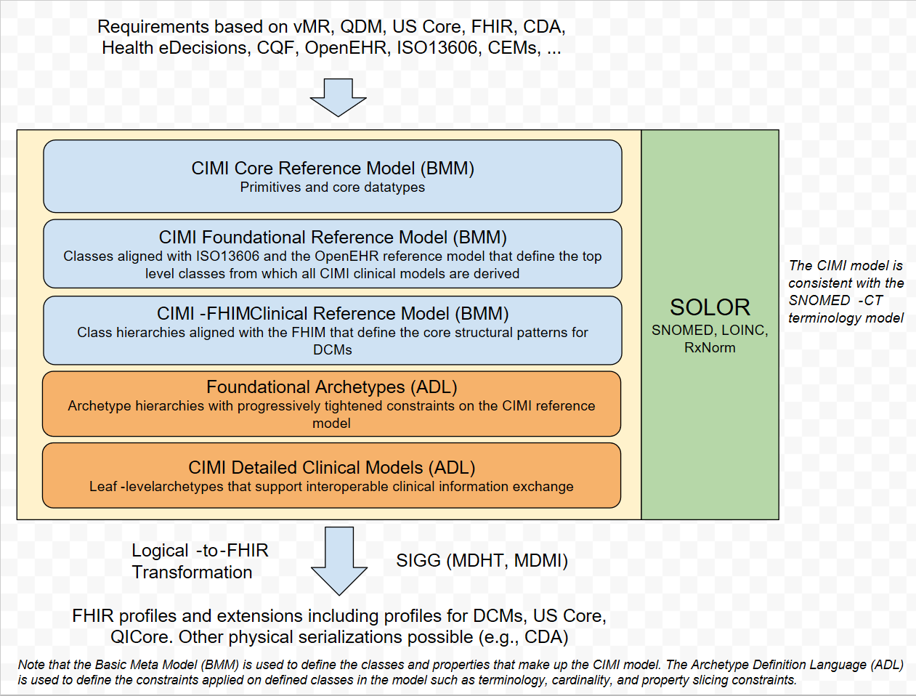

1. The **CIMI architectural framework** is coming into fruition with its second ballot (Jan and May 2017) and will include FHIR implementation artifacts in the September 2017 ballot, based on the skin assessment pilot project. The CIMI architectural framework includes:
   1. Basic Meta Model (BMM)
      1. Stable Core, which is HL7 balloted and CM controlled, which may change for new domains
         1. BMM Lvl-1 Core,
         2. BMM Lvl-2 Foundation, e.g., Observations
         3. BMM Lvl-3 Clinical Reference Architypes e.g., Lab Observations
         4. BMM Lvl-4 Clinical Reference Patterns, e.g., Quantitative Lab Obs., Qualitative Lab Obs., Titer Lab Obs.
      2. Crowd-Sourced Profiles-and-Extensions, which can change for particular application needs.
         1. BMM Lvl-4 Clinical Patterns
         2. DCM Lvl-5 Clinical Detailed Clinical Models
   2. Principles, such as preferred separation models of structure/use and models of meaning, post-coordinated terminology
   3. Methodology for development/reuse of IIM&T artifacts supporting HIT SDLC interoperability
   4. Tools: Realizing that the core CIMI team is spread thin, emphasis will be placed on tool specification-and-development to support crowd-sourcing and crowd-curation of level 4 and level 5 models. Tooling is also needed/being-developed for graphical-user-interfaces and visualization entry screens
      1. see <http://clinfhir.com/> automatically leading to FHIR specification language and FHIR profiles-and-extensions.
      2. <http://www.openehr.org/ckm/>
   5. CIMI Model Browser at <https://www.opencimi.org/model-browser>
   6. See reference documents for ballot materials <http://models.opencimi.org/cimi_doc/>
   7. **ACTION**: FHIR STU3 patterns drive resources for consistency
   8. **ACTION (Claude Nanjo)**: alignment of CIMI & QDM
   9. The CIMI wound assessment pilot project has guided major strides in
      1. Separation Principle: SHEX (shape expressions schema/mapping for RDF) SHEX.IO
         1. Separation of model-of-structure and SOLOR (SNOMED, LOINC, RxNorm) model-of-meaning
         2. SNOMED CT Observation model separation of Topic (e.g., Evaluation vs. Assertion) and Context (anatomical location, state, provenance)
      2. SOLOR/SNOMED Ontology Conundrum illustrated by the concept of “skin color”; where, nurses might use the terms, “cyanotic (purple), ruddy, flush (red), alcoholic (blue) or jaundice (yellow)”, which in and of themselves are not “colors”; but might be indications of disease. These factors are complicated by race and state (e.g., trauma, infected wound). Ontological reasoning is impossible without both topic and context in these situations.
   10. **Bernd Bobble** presented the current ISO 13606 Part 1, Annex C (see appendix) recommended Lambda calculus / recursive-cube approach to potentially dealing with this type of complexity within the tool suite, while maintaining intuitive simplicity for the clinicians’ user interface.
   11. **Mark Kramer**, MITRE presented his domain-specific textural language (DSL) approach versus or concurrent-with the more graphical “Physicians on FHIR” approache.
   12. Everyone concurred on the value of collaborative development shared/concurrent full software-development-lifecycle (SDLC) model-driven-development (MDD) tools; where, clinicians have an intuitive requirements-specification user-interface supported by MDD tools resulting in consistent, traceable, efficient and effective FHIR, CDA, etc. implementation artifacts for vendors, integrators, etc. to use.
   13. **Thursday Q4:** CIMI roadmap to consistent and traceable FHIR Artifacts. This plan requires further refinement
       1. **Jan 2017 Proposed Plans for May 2017 Ballot:** The status was NOT explicitly discussed; where, incomplete tasks need to be moved forward in the roadmap.
          1. Modeling. #1 priority. [Claude, Galen]
             1. BMM: Reference model including pilot content

*BMM was refined for Clinical Statement Topic and Context*

* + - * 1. ADL: top level archetypes including pilot content

Reference Architypes and Reference Patterns were specified for the May ballot.

* + - * 1. FHIM generation: #4 priority [Galen]

*FHIM transformation for Reference Architypes and Reference Patterns is approximately 60% complete.*

*FHIM generation of BMM level 3 is targeted for the Sep 2017 ballot.*

* + - 1. Pilots
         1. Skin Wound Assessment: content is #1 [Jay, Susan]

Expression #1 [Jay]

Quality measure #2 [Claude, Ken]

* + - * 1. Zika measure #3
        2. Pediatric Bilirubin Management CDS #2 (Ken)
        3. Immunization Management #3 (Steve with Gary Dickinson, EHR WG)
        4. Refine PROCEDURE and CONTEXT based on Pilots #3
        5. US Core / QI Core / CIMI Archetype integration #1 [Claude]
        6. Family Planning Annual Report (FPAR) – HSPC pilot with ACOG #?
        7. Device interfaces MDEpiNet. #3 (Julia)
      1. Tooling
         1. FHIR conversion (2e) #2
         2. Code generation – Java classes to represent the CIMI models #3
         3. Authoring

Visualize #2 [Patrick]

Version management/governance #3

STAMP #4

* + - * 1. Repository (e.g., Simplifier) #2

Visualization #3 [Michael]

Get requirements to Furore #1 [Claude]

* + - * 1. libraries to manipulate BMM/ADL #0 [Claude]
        2. Documentation [Patrick, Editor]

Overview/marketing pitch [Stan, Jay, Claude. Steve, Nona, Ask Laura.]

Practitioners' Guide, for clinicians, Analysts and non-CIMI SMEs. [Steve, Nona]

Style guide [Susan, Jay, Steve]

Architecture guide [Claude]

Refine CIMI Process Definition for CIC #3 [Steve, Claude, Jay, Galen]

Content uptake & governance process [Jay]

Generation tool [Michael]

* + - * 1. Terminology

Author: SOLOR / TermWorks – get access #1 [Keith/Susan]

Publishing #2

* + 1. **May 2017 Proposed Plans for Sep 2017 Ballot**
       1. Models for lab data and regeneration of leaf node models (Stan, Joey, Galen Patrick, Susan, Katy Holck (pub health, lab), Donna Redley RN informaticist). See 2015 Models.opencimi.org as baseline
          1. Work needs to be done to improve the quality (value sets)
          2. Include validation (compare CEM-LOINC (axes) structures to CIMI & FHIR)

e.g., Fetus.HeartRate

* + - * 1. Start with highest volume and most used data elements
        2. Use the SNOMED description logic maps that were generated as part of the SNOMED – LOINC agreement
        3. Use of the “invariant” anchor patterns, Grahame’s “dictionaries”, abilities to do transformations of instance data
        4. Claude – hierarchy of types: quantitative, coded, ordinal lab, detailed clinical models
      1. Vital Signs
         1. CIMI models for vitals map-and-gap against FHIR models
         2. Compare/validate to/with US Core/FHIR Core, Intermountain CEMs, MHS Cerner, VA
      2. Document refset requirements (intensional, extensional) for CIMI binding and tooling
         1. STAMP versioning, implications of versioning and model dependencies for concepts that are referenced in CIMI models – Susan Matney
      3. Clarification of binding – static versus dynamic binding, and related issues, allows conformance testing, binding in abstract types – Rob McClure
      4. Further flesh out core reference models – Claude
         1. Allergies/Intolerance/Adverse events (Claude working with Russ)
         2. Action (flesh out stub)
         3. Event (flesh out stub)
         4. Medications: order, administration, dispense (FHIM)
         5. Devices (FHIM model very mature IAW V3 & FHIR, pull in device WG)

Claude: governance issue

Wait on devices till medications done

* + - * 1. Subtyping of results for radiology and imaging
        2. Care plans (Richard: CDS & CQI working on this)

Susan & Stan: Multiple patterns (panel on observations)

* + - * 1. Harmonizing with QDM, FHIM, FHIR, CQI, VMR
      1. Tooling (Claude)
         1. Galen: CIMI do reference-architype models, in BMM, and crowd-source foundational patterns & DCMs

BMM level 1-3, Data types, foundational models, (FHIM) clinical architypes

BMM “constraint” level 4: Patterns & semantic anchors (Who is responsible? (CIMI vs crowd-source)

BMM “constraint” level 5: DCMs

* + - * 1. Generation of FHIR profiles from CIMI models
        2. Model authoring tools
      1. Generate BMM from harmonized FHIM, (Galen harmonized FHIM target date July 1)
      2. Model request spreads sheet import (Susan & Richard)
      3. Strategy for testing of models
      4. Pharm (Claude): CIMI vs. pharmacy models. Claude & Galen meet during Pharm meetings to align patterns and FHIR resources and patterns. Pharm be source of requirements and own the harmonized logical models.
      5. 2018 Option (Richard): Extend process to radiology
         1. Radlex orders and results/findings separate; where, findings are lower quality
         2. NANCY: shared procedure file in 2018-2019.
         3. Map LOINC to CIMI DCMs
         4. Tooling, databases (SNOMED & versioning) and process guide for scaling concept creation, distribution, CIMI binding-and-refsets (in SOLOR),

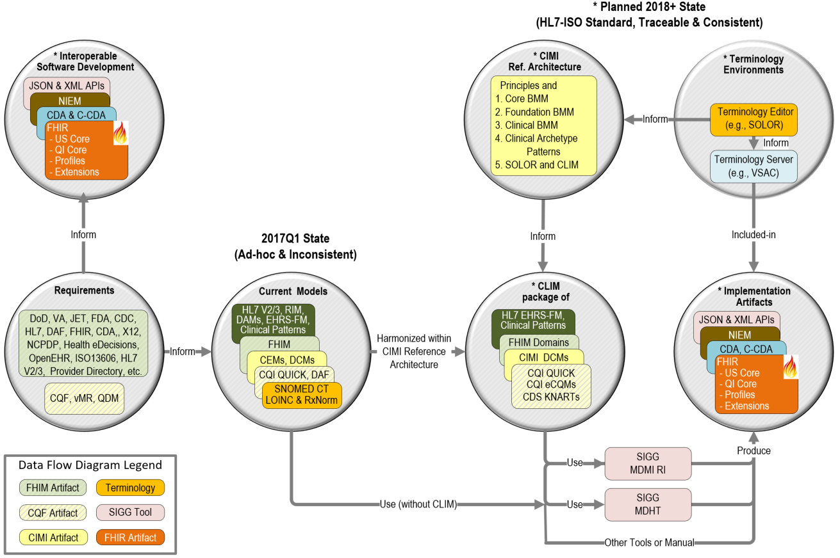

**Figure 2 The HL7 IIM&T Path to Plug-and-Play Computable Semantic-Interoperability of FHIR, CDA, etc.**

1. **May 7-12 HL7 Workgroup Conclusion**: Collaborative-convergence of the SOLOR-FHIM-CIMI-CQF IIM&T and associated governance, principles, methodology and MDD tools with FHIR crowd-sourced content and associated governance, methodology and tools can provide a pragmatic win-win full SDLC path to plug-and-play computable-semantic-interoperability healthcare objective to achieve patient-healthcare value, e.g., faster-better-cheaper “learning health systems” and ‘patient-centric population-based medicine”.
2. **Appendix A: Acronyms**

*“When I use a word, it means just what I choose it to mean — neither more nor less.” [Alice in Wonderland, 1892, Lewis Carroll]*

|  |  |  |  |
| --- | --- | --- | --- |
| BMM | CIMI Basic Meta Model components | ISAAC | VA tool for SOLOR |
| CEM | Intermountain Clinical Element Models | ISO | International Standards Organization |
| CIMI | HL7 Clinical Information Model Initiative | JIF | VA/DOD Joint Incentive Fund |
| CLIM | HL7 Common (Clinical) Logical Information Model | KNART | CDS Knowledge Artifact |
| CQI | HL7 Clinical Quality Information | LOINC | Logical Observation Identifiers Names and Codes |
| CQF | HL7 Clinical Quality Framework | MDHT | Model Driven Health Tools |
| DAF | ONC Data Access Framework | MDMI | Model Driven Message Interoperability |
| DCM | Detailed Clinical Model | ONC/OST | US Office of the Natl. Coordinator / Office of Science and Tech. |
| eCQM | CQI Electronic Clinical Quality Measure | PMP | Program Management Plan |
| STU | HL7 Standard for Trial Use | PSS | Project Scope Statement |
| EDW | Electronic Data Warehouse | QUICK | CQI Quality Information and Clinical Knowledge logical model. |
| FDA | US Federal Drug Agency | RXNorm | US National Library of Medicine naming system for drugs |
| FHA | US Federal Health Architecture | SIGG | Standards Interoperability Guide Generator |
| FHIM | US Federal Health Information Model | SOLOR | SNOMED extension for LOINC & RXNorm |
| FHIR | HL7 Fast Health Information Resource | TLC | ONC/OST Technical Learning Center |
| HIEA | DoD VA IPO Health Interoperability Exchange Alliance | VA | US Veterans Administration |
| HcDir | ONC-FHA Provider Healthcare Directory. | VCS | Version Control System for collaboration |
| IPO | US DoD and VA Interagency Program Office | VSAC | NLM Value Set Authority |

# Acronyms and Links

* **BMM** is CIMI Reference Model (Information Architecture) Basic Meta Model components
* http://wiki.hl7.org/index.php?title=CIMI_Practitioners%27_Guide
* **CDA** is HL7 Clinical Data Architecture.
* See http://www.hl7.org/implement/standards/product_brief.cfm?product_id=258
* **C-CDA** is HL7 Consolidated CDA.
* See http://www.hl7.org/implement/standards/product_brief.cfm?product_id=379
* **CEM** is Intermountain Clinical Element Models. See http://www.opencem.org/#/
* **CDS** is HL7 Clinical Decision Support workgroup. Seehttp://wiki.hl7.org/index.php?title=Clinical_Decision_Support
* **CIMI** is HL7 Clinical Information Model Initiative.
* See http://wiki.hl7.org/index.php?title=Clinical_Information_Modeling_Initiative_Work_Group
* **CIMI Principles** See http://wiki.hl7.org/index.php?title=CIMI_Practitioners%27_Guide
* **CIMI Reference Models (aka Information Architecture)** See http://wiki.hl7.org/index.php?title=CIMI_Practitioners%27_Guide
* **CLIM** is HL7 Clinical Logical Information Model Package of CIMI-Harmonized SOLOR, FHIM, CQF, CIMI DCMs and CQI KNARTs
* where, independent organizations maintain the component models and HL7 periodically configuration manages, ballots and standardizes them.
* **CQF** is ONC Clinical Quality Framework. See http://wiki.hl7.org/index.php?title=Clinical_Decision_Support
* **CQI** is HL7 Clinical Quality Initiative workgroup. See http://wiki.hl7.org/index.php?title=Clinical_Quality_Information
* **DAF** is ONC Data Access Framework (US Core). See http://wiki.siframework.org/Data+Access+Framework+Homepage
* **DCM** is CIMI Detailed Clinical Models. See http://www.opencimi.org/model-browser
* **FHIM** is Federal Health Information Model. FHIM specifies 30+ healthcare domains. http://FHIMS.org
* **FHIR** is HL7 Fast Healthcare Information Resource standard and workgroup. Seehttp://wiki.hl7.org/index.php?title=FHIR
* **HcDir** is ONC-FHA Provider Healthcare Directory. Seehttp://wiki.siframework.org/Provider+Directories
* **IIM&T** Is CIMI-sponsored HL7 Integration of Information Models & Tools Project.
* http://wiki.hl7.org/index.php?title=CIMI_Practitioners%27_Guide
* **JET** is DoD-VA Joint Exploratory Team.
* **KNART** is CDS Knowledge Artifact. See http://www.hl7.org/implement/standards/product_brief.cfm?product_id=337
* **MDHT** is SIGG Model Driven Health Tool. See https://projects.eclipse.org/proposals/model-driven-health-tools
* **MDMI** is SIGG Model Driven Message Interoperability.
* The present MDMI Referent Index (RI) scope is the US Core; where, FHIM is used for data-element value-sets.
* FHA’s MDMI RI supports all MU2 data elements and >90% of the C-CDA model.
* See http://www.omg.org/mdmi/and http://www.omg.org/spec/MDMI/
* See at https://github.com/MDMI/ReferentIndexContent
* **NIEM** is National Information Exchange Package. See https://www.niem.gov/
* **QI Core** is FHIR Quality Improvement Core Implementation Guide. See https://www.hl7.org/fhir/qicore/qicore.html
* **QUICK** is CQI Quality Information and Clinical Knowledge logical model, used to specify eCQMs and FHIR QI Core.
* See https://www.hl7.org/documentcenter/public_temp_315E0F18-1C23-BA17-0C73398BA144AB5D/wg/cqi/Defining_eCQMs_Using_CQL.pdf
* **RI** is SIGG-MDMI Referent Index. See https://github.com/MDMI/ReferentIndexContent
* **SIGG** is FHA Standards Implementation Guide Generator
* **SOLOR** is VA’s SnOmed LOinc, Rxnorm. HSPC hosts the SOLOR terminology editing environment.
* **VSAC** is NLM Value Set Authority Center. <https://vsac.nlm.nih.gov/>

1. **Appendix B: Clinicians on FHIR Tool** [**http://clinfhir.com/**](http://clinfhir.com/)
2. **Patient Viewer** to display resources for a specific patient, using a number of different views such as a list by resource type, json & tree views, encounters by condition, numeric Observation charting and graphical relationship views. There is also the option to add a new patient, and to create sample data for that patient; where, patient resources are stored on the Data Server. The server should support the $everything operation against Patient.
3. **Scenario Builder** is used to join together the resources needed to represent a specific clinical scenario. It can use Core Resource types, Profiles and Logical models as it does this. The intention is to help people understand how resources can tell a clinical story, and to validate that the resource types available (including profiles) are sufficient. Note that the builder still has issues with more complex resource types - this is a work in progress; where, patient information is on the Data Server. Profiles on the Conformance server. ValueSets on the Terminology server.
4. **Logical Modeler** allows the creation of a model that represents a particular interoperability requirement in a format that is easy to use. It uses FHIR datatypes, and can be based on an existing resource type or completely 'ad hoc'. It is intended to act as a 'bridge' between Modeler and User, and can act as the basis for the generation of the profiling components required by FHIR; where, models are saved on the Conformance Server. Can reference ValueSets from the Terminology server.
5. **CodeSystem builder** defines a set of Concepts from which a ValueSet provides possible values for a resource element. The actual 'binding' between CodeSystem and element is done by the ValueSet. This component allows you to build (and edit) a CodeSystem, and optionally builds the ValueSet as well; where, CodeSystems are saved on the Terminology Server.
6. **Extension Definition builder v**iews and builds extension definitions. These can be defined and applied to the Logical Model, which will allow them to be included in the generated Profile; where, extension definitions are saved on the Conformance Server
7. **ValueSet explorer l**ets you view existing ValueSets. The builder works best with SNOMED (at the moment); where, ValueSets are stored on the Terminology Server
8. **Query Tool a**llows ad hoc queries against any FHIR server and can access any compliant FHIR server
9. **Concept Mapper can e**dit concept maps. Experimental; but, can access any compliant FHIR server

# Appendix C: ISO 13606 Annex C (informative) Cross-Domain Interoperability

# C.0 Cross-Domain Interoperability

Interoperability, defined by IEEE as “ability of two or more systems or components to exchange information and to use the information that has been exchanged” has evolved during the last 25 years from structured messaging (e.g. EDI, HL7 messaging) over sharing concepts (e.g. openEHR Archetypes, EN/ISO 13940 ContSys concepts) - both represent the data/information exchange paradigm - to cooperation at application level (e.g. Web services). Nevertheless, all those standards-based interoperability approaches are restricted to computer-to-computer communication, representing information according to the domain independent ISO/IEC 10746 Information technology - Open Distributed Processing - Reference Model or to domain-specific information models such as ISO/HL7 21731 Health informatics - HL7 Version 3 - Reference Information Model.

Meeting the objectives of improving safety, quality and efficiency of care with information and communications (**ICT**) support requires advancing interoperability between computer systems towards a business process specific co-operation of actors representing the different domains participating in the business case. For that purpose, the agreed domain knowledge, but also individual (language, education, skills, experiences, social and psychological aspects, etc.) and environmental context have to be represented correctly and formally for integration in the ICT system as part of the business system. As the domain experts involved describe specific aspects of that business system in a specific context, using their specific terminologies and ontologies, methodologies and frameworks, the resulting informational representations are quite inconsistent, requiring a peer-to-peer interoperability adaptation process. Adapting existing standardized informational representations of domain-specific use cases to changing contexts or including other domains requires another common harmonized informational representation, resulting in permanent revisions of specifications.

It is impossible to represent the highly complex, highly dynamic, multi-disciplinary/multi-domain healthcare system by one domain‘s terminology/ontology or - even worse - by using ICT ontologies. The same holds when using one domain’s representational style and models or standards as reference or master all the interrelated components must be adapted to.

The alternative is an abstract domain-independent representation of systems using Universal Type Theory and corresponding logics as philosophers do to describe the universe. The mathematical concept representation in combination with systems engineering methodologies allows representing any system architecturally (i.e. the system’s components, their functions and internal as well as external relations) by generically describing its composition/decomposition as well as the aspects (domains) of the system relevant in a specific context (e.g. business case). For correctly and formally representing the concepts and relations of the domain-specific subsystems involved in that business case, those subsystems are represented by their corresponding approved domain ontologies, resulting in a system-theoretical, architecture-centric, top-level ontology driven approach [1, 2]. The reference architecture model can be used recursively, so representing, e.g., the real-world systems’ continuum from elementary particles to the universe (Figure 1).

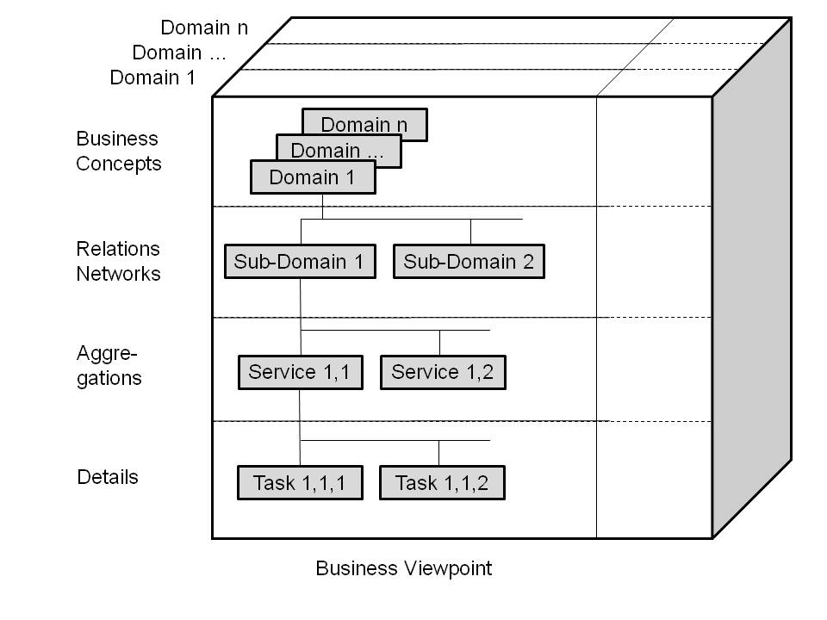

**Figure C1. Interoperability Reference Architecture Model granularity levels**

By combining that model with ISO/IEC 10746[3], the Interoperability Reference Architecture Model (introduced in the nineties as Generic Component Model - GCM) as well as the applicable rules - the Interoperability Reference Architecture Model Framework - (also known as GCM Framework) is completed (Figure 2) [3].

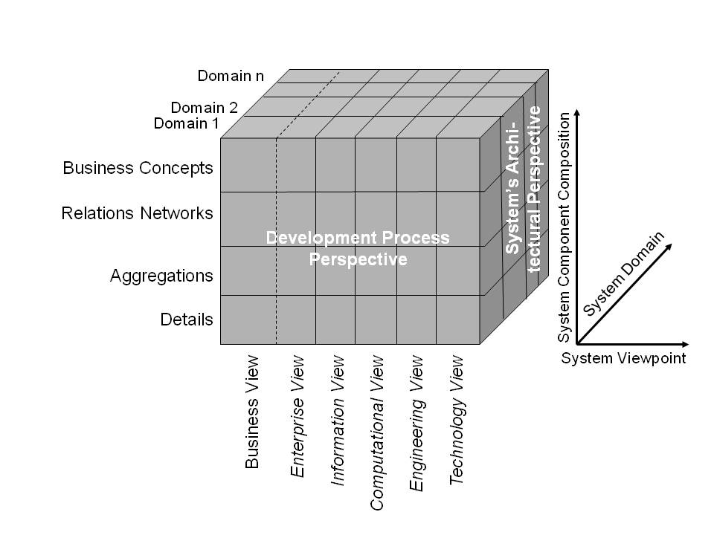

**Figure C2. The Interoperability Reference Architecture Model**

This Interoperability Reference Architecture Model allows consistently transforming and interrelating any domain-specific subsystem’s structure and behavior (e.g. domain-specific standards and specifications) by ontologically representing its concepts and relationships at the real-world system component’s level of granularity. In other words, the domain-specific subsystem (e.g. a domain-specific standard or specification) is re-engineered using the Interoperability Reference Architecture Model, by that way providing a standardized interface to that specification (Figure 3).

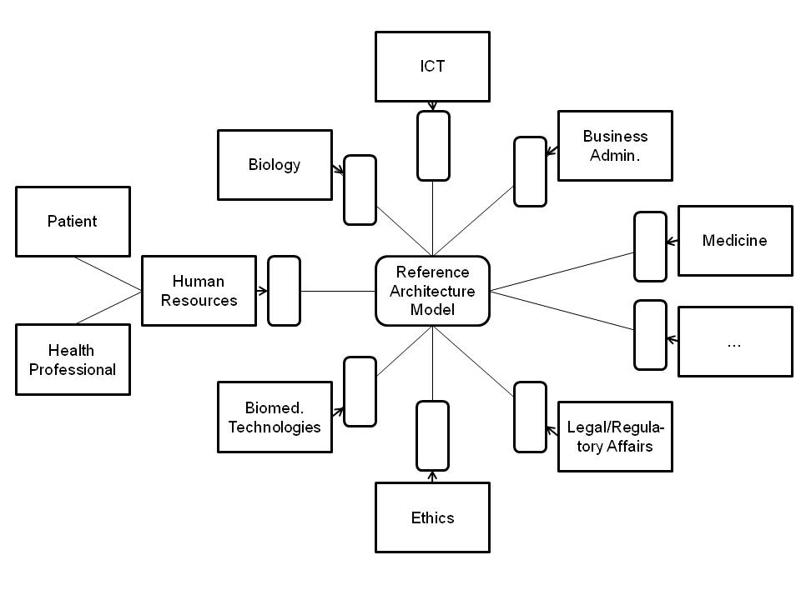

**Figure C3. Interoperability mediated by the GCM Reference Architecture Model [2]**

*Bound to the GCM Framework, inter-domain relationships must happen at the same level of granularity* [4]. To get there, intra-domain specializations/generalizations have to be performed. In summary, the Interoperability Reference Architecture Model supports ontology harmonization or knowledge harmonization to enable interoperability between existing systems, standards and solutions of any level of complexity without the demand for continuously adapting/revising those specifications.

As an example, re-engineering of ISO 13606 “EHR communication” Reference Model (colored components) into the GCM is shown in Figure 4, thereby just considering the domains addressed in that model. On that basis, the harmonization of ISO 13606 with other specs such as HL7 v2 and v3 [4, 5] – a permanent challenge Standards Development Organizations are faced with – can be easily performed. The figure shows a mixture of different viewpoints requiring advanced transformations not considered in the standard. Furthermore, there is a vast amount of explicit knowledge missing in ISO 13606 but necessary for harmonization as demonstrated by the non-colored components, which complete the architectural model. Just the ISO 13606 components presented in three dimensions represent valid architectural components in the reference architecture model. The others (colored rectangles) have to be transferred into valid components.

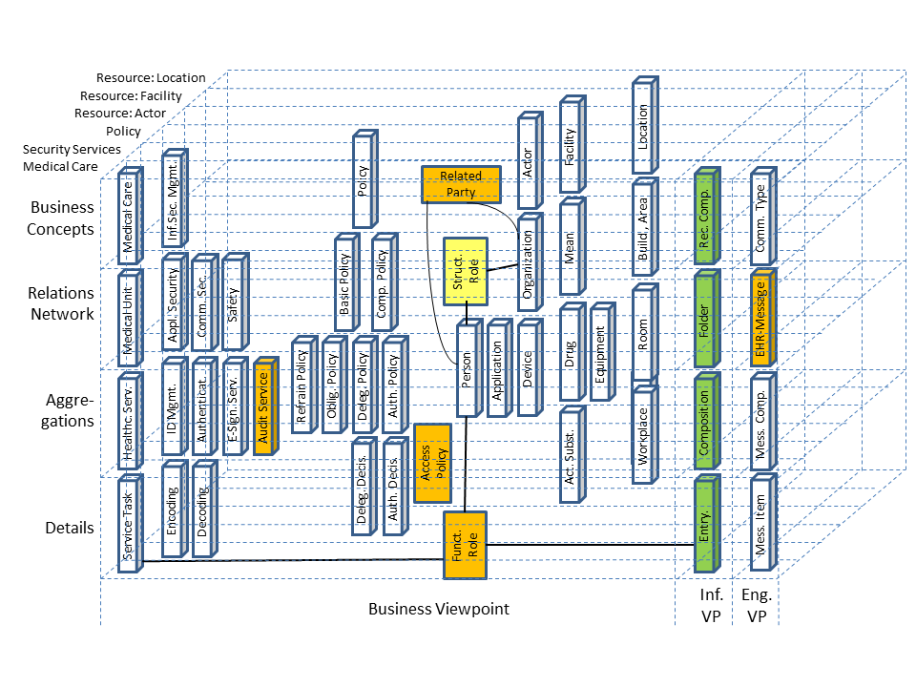

**Figure C4. Re-engineering example of the ISO 13606 Reference Model**

The described process can be automated. The same holds for transforming the cross-domain, harmonized, consistent informational representation of the complex business system into the different ISO/IEC 10746 views for analyzing, designing, implementing and maintaining the related ICT solution.

The presented approach has been successfully deployed in several cross-domain ISO specifications, such as ISO 22600 Health informatics - Privilege management and access control, ISO 21298 Health informatics - Functional and structural roles, HL7 Composite Security and Privacy Domain Analysis Model. Its feasibility has been practically demonstrated for automatically harmonizing HL7 v2.x and HL7 v3 specifications [5] or for automatically designing inter-domain Web services to facilitate multi-disciplinary approaches to Type 2 Diabetes Care management [6, 7]. The approach also allows a comparative analysis and evaluation of ICT Enterprise Architectures [8].

# C.1 References

1. Blobel B. Knowledge Representation and Management Enabling Intelligent Interoperability – Principles and Standards. Stud. Health Technol. Inform. 186;2013:3-21.
2. Blobel B, et al. Ontological Foundations of the GCM Reference Architecture Model and Approach. Submitted to Methods Inf Med.; 2016.
3. Blobel B. Architectural approach to eHealth for enabling paradigm changes in health. Methods Inf Med 2010; 49,2: 123-134.
4. Oemig F, and Blobel B. A Formal Analysis of HL7 Version 2.x. Stud. Health Technol. Inform. 169;2011:704-708.
5. Oemig F, Blobel B. A Communication Standards Ontology Using Basic Formal Ontologies. Stud. Health Technol. Inform. 156;2010:105-113.
6. Uribe GA, Blobel B, López DM, Schulz S. A Generic Architecture for an Adaptive, Interoperable and Intelligent Type 2 Diabetes Mellitus Care System. Stud. Health Technol. Inform. 211;2015:121-131.
7. Uribe GA, Blobel B, López DM, Ruiz AA. Specializing Architectures for the Type 2 Diabetes Mellitus Care Use Cases with a Focus on Process Management. Stud. Health Technol. Inform. 211;2015:132-142.
8. Blobel B, Oemig F. The Importance of Architectures for Interoperability. Stud. Health Technol. Inform. 211;2015:18-56.

# C.2 Definitions

* A **model** is a partial representation of reality. It is restricted to attributes the modeler is interested in. Defining the pragmatic aspect of a model, the interest is depending on the addressed audience, the reason and the purpose of modelling the reality and using the resulting model for a certain purpose and for a certain time instead of the original. Therefore, the model as a result of an interpretation must be interpreted itself.
  + A purpose of models is to create knowledge. An outcome of developing mathematical models is that it helps model builders and decision makers understand the relationships between important variables in a business situation. On the other hand, description and especially the interpretation of real systems are based on knowledge.
* A **reference model** is a general model describing a class of facts of a domain of discourse.
  + It enables the derivation of instances.
  + It can be used for comparing different models dealing with instances of the same class of facts.
  + As development patterns, it enables the reuse of specifications.
* A **concept** is a model. It shall be uniquely identifiable, accepted by experts and users, as well as independent. A concept as a knowledge component can be specialized and generalized as components can.
* **System** groups structurally and/or functionally interrelated components, which are separated from the environment defining components by system boundaries
  + Alternative definition: The system is separated from the entirety by selecting components with common properties relevant in the business case‘s context.
  + Systems interact with their environment.
  + Systems can be composed (aggregated) to super-systems or decomposed (specialized) to sub-systems.
* **System Architecture** describes its components, their functions and relations.
* **Interoperability** describes motivation, willingness, ability, and capability to cooperate for achieving common goals or business-objectives.
* **Reference architecture** is a reference-model for a class of architectures.
* **Policy** is the set of rules for selecting components and functions as well as constraints of the relations according to a business case are called policies. Policies define the intended behavior of a system.

**Appendix D: CIMI-Sponsored HL7 IIM&T-Projects Reference Documents**

*“It is not the critic who counts; not the man who points out how the strong man stumbles, or where the doer of deeds could have done them better. The credit belongs to the man who is actually in the arena, whose face is marred by dust and sweat and blood; who strives valiantly; who errs, who comes short again and again, because there is no effort without error and shortcoming; but who does actually strive to do the deeds; who knows great enthusiasms, the great devotions; who spends himself in a worthy cause; who at the best knows in the end the triumph of high achievement, and who at the worst, if he fails, at least fails while daring greatly, so that his place shall never be with those cold and timid souls who neither know victory nor defeat.” [Theodore Roosevelt, Apr 23, 1910, Sorbonne, Paris, France]*

HL7 IIM&T Project Scope Statements <https://1drv.ms/f/s!AlkpZJej6nh_lIQOuPJcL2rf5BVoXQ>

IIM&T Technical Forum Summary <https://1drv.ms/w/s!AlkpZJej6nh_k9gyRVADgOvM5SlJkQ>

IIM&T Briefing Slides <https://1drv.ms/p/s!AlkpZJej6nh_k9dE-b_DAO8HSNNT6Q>

IIM&T Newsletters <http://wiki.hl7.org/index.php?title=CIMI_Newsletters>

IIM&T Reports <https://1drv.ms/w/s!AlkpZJej6nh_k9dQ2qQnRuQM8gbu8A>

CIMI web-site [https://www.opencimi.org](https://www.opencimi.org/)

* CIMI BMM Browser <http://models.opencimi.org/cimi_doc/>
* CIMI Architype-Model Browser <https://www.opencimi.org/model-browser>
* CIMI Wiki <http://wiki.hl7.org/index.php?title=Clinical_Information_Modeling_Initiative_Work_Group>
* CIMI Minutes <http://wiki.hl7.org/index.php?title=CIMI_Minutes>
* CIMI Ballot Materials <https://drive.google.com/drive/folders/0ByrVwEEPQjMyazNLMUNFZ2YtNk0>
* CIMI Architecture and Style Guides <http://wiki.hl7.org/index.php?title=CIMI_Modeling,_Architecture,_Methodology_and_Style_Guides>

CIMI Practitioners Guide [http://wiki.hl7.org/index.php?title=CIMI_Practitioners%27_Guide](http://wiki.hl7.org/index.php?title=CIMI_Practitioners'_Guide)

US CORE Wiki <https://oncprojectracking.healthit.gov/wiki/display/TechLabSC/DAF+Home>

Skin and Wound Assessment Pilot Wiki <http://wiki.hl7.org/index.php?title=PC_CIMI_Proof_of_Concept>

SNOMED CT: <http://ihtsdo.org/index.html>

Expression Constraint Guide <https://confluence.ihtsdotools.org/display/DOCECL/Expression+Constraint+Language+-+Specification+and+Guide>

1. In-accordance-with DoD Instruction 5000.75 Business System Requirements and Acquisition, Feb 2, 2017, establishes policy for the use of the business capability acquisition cycle (**BCAC**) requirements and acquisitions, i.e., Software Development Lifecycle (**SDLC**).
2. CLIM is the healthcare Common Logical Information Model product of the CIMI sponsored HL7 IIM&T project.
3. **Reference Model of Open Distributed Processing** (**RM-ODP**) is a [reference model](https://en.wikipedia.org/wiki/Reference_model) in [computer science](https://en.wikipedia.org/wiki/Computer_science), which provides a co-ordinating framework for the standardization of [open](https://en.wikipedia.org/wiki/Open_system_(computing)) [distributed](https://en.wikipedia.org/wiki/Distributed_systems) processing (ODP). It supports [distribution](https://en.wikipedia.org/wiki/Distributed_systems), [interworking](https://en.wikipedia.org/wiki/Interoperability), [platform](https://en.wikipedia.org/wiki/Platform_(computing)) and technology independence, and [portability](https://en.wikipedia.org/wiki/Porting), together with an [enterprise architecture framework](https://en.wikipedia.org/wiki/Enterprise_architecture_framework) for the [specification](https://en.wikipedia.org/wiki/Specification) of ODP systems.